

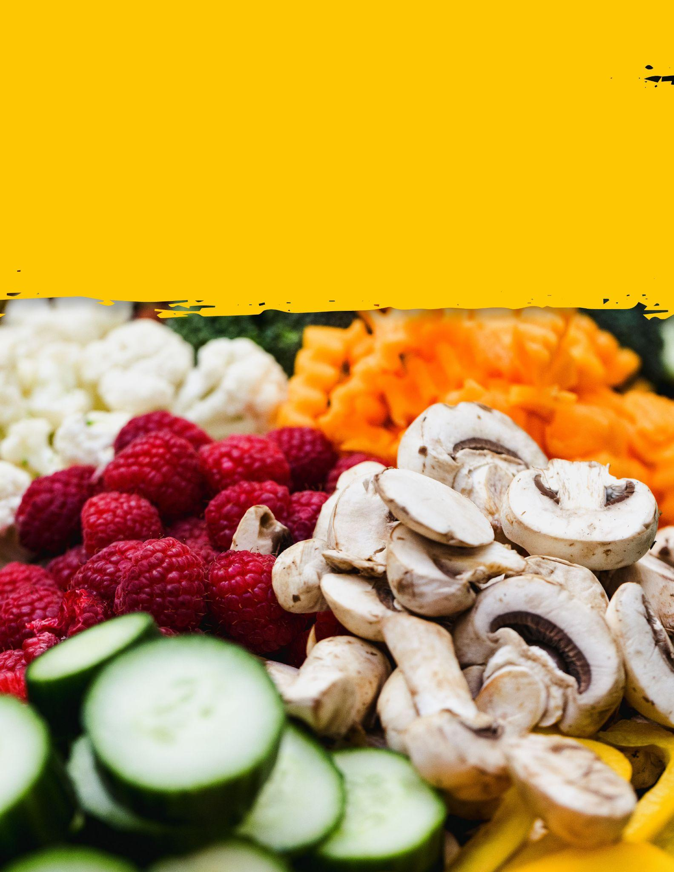
The Fresh Table
A book journal about vegetables, health and lifestyle







All about vegetables
There are dozens of types of whole grains. Here are some of the most common ones.
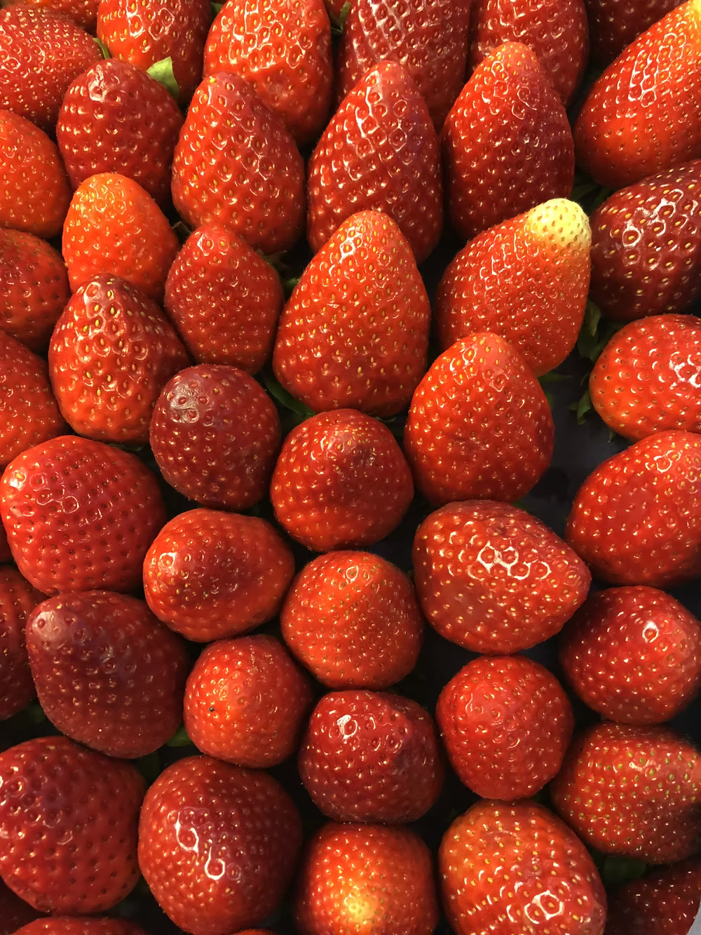
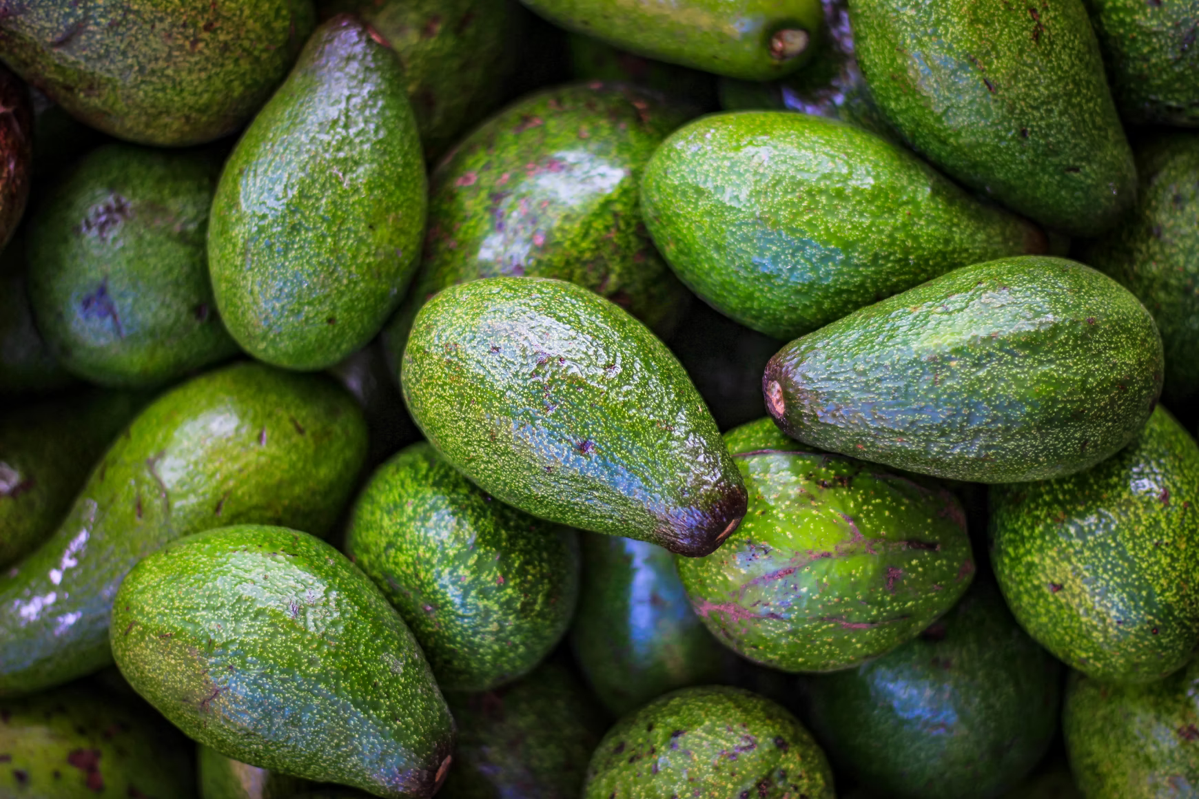
Avocado
Avocado, also called alligator pear, fruit of Persea americana of the family Lauraceae, a tree native to the Western Hemisphere from Mexico south to the Andean regions. Avocado fruits have greenish or yellowish flesh with a buttery consistency and a rich, nutty flavour. They are often eaten in salads, and in many parts of the world they are eaten as a dessert. Mashed avocado is the principal ingredient of guacamole, a characteristic sauce in Mexican cuisine. Avocados provide thiamin, riboflavin, and vitamin

Strawberries
Strawberries are among the most beloved of fruits.
They come from a plant called ‘fragaria’ and are members of the rose family.Despite its name, the strawberry isn’t a true berry.Technically, it is an aggregate accessory fruit, meaning that the fleshy part is derived not from the plant’s ovaries but from the receptacle (the thickened part of a stem) that holds the ovaries.Each apparent “seed” (achene) on the outside of the fruit is actually one of the ovaries of the flower, with a seed inside it.The fruit is widely appreciated for its characteristic aroma


Interesting facts about vegetables

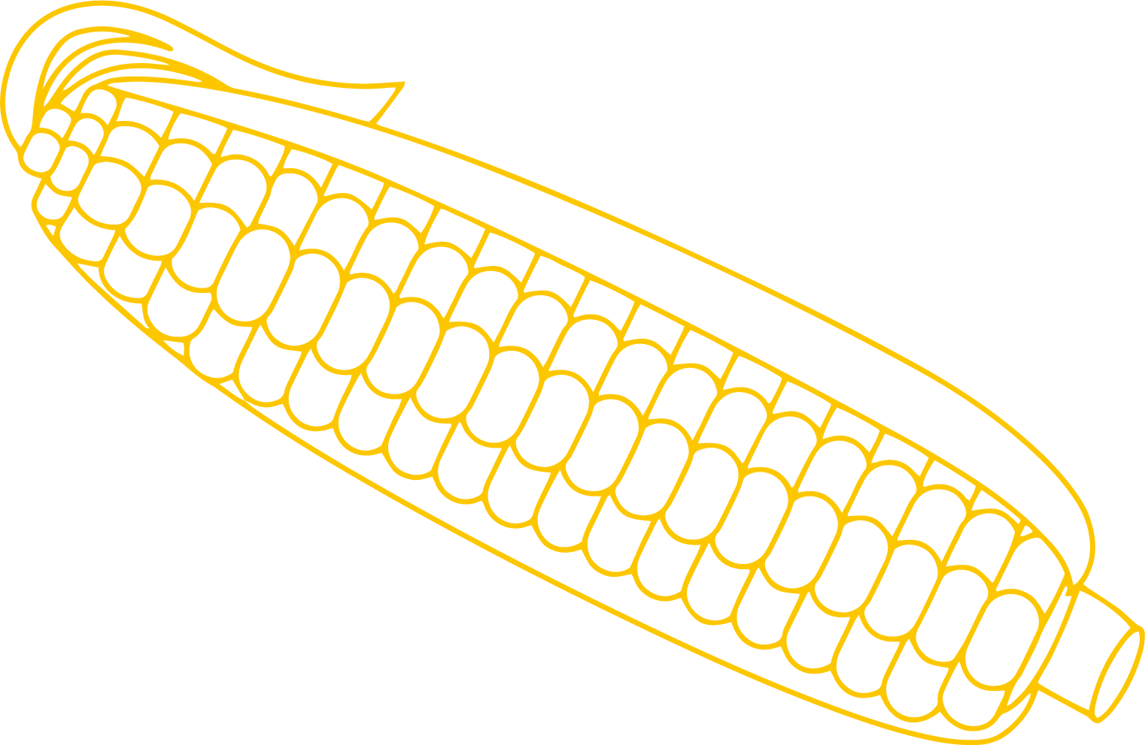
Vegetables are parts of plants that are consumed by humans as food.

The term vegetable usually refers to the edible portions of certain herbaceous plants roots, stems, leaves, flowers, fruit, or seeds.These plant parts are either eaten fresh or prepared in a number of ways, usually as a savory, rather than sweet, dish.Originally, vegetables were collected from the wild by hunter-gatherers and entered cultivation in several parts of the world, probably during the period 10,000 BC to 7,000 BC, when a new agricultural way of life developed.

Virtually all of the more important vegetables were cultivated among the ancient civilizations of either the Old or the New World and have long been noted for their nutritional importance.
As the birth of modern human civilizations, vegetables were identified as the source of great medicinal and nutritional power.Vegetables are usually classified on the basis of the part of the plant that is used for food.The root vegetables include beets, carrots, radishes, sweet potatoes, and turnips.

Stem vegetables include asparagus and kohlrabi.
Among the edible tubers, or underground stems, are potatoes.

The leaf and leaf stalk vegetables include brussels sprouts, cabbage, celery, lettuce, rhubarb, and spinach.Among the bulb vegetables are garlic, leeks, and onions.

The head, or flower, vegetables include artichokes, broccoli, and cauliflower.

The fruits commonly considered vegetables by virtue of their use include cucumbers, eggplant, okra, corn, squash, peppers, and tomatoes.
Seed vegetables are usually legumes, such as peas and beans.

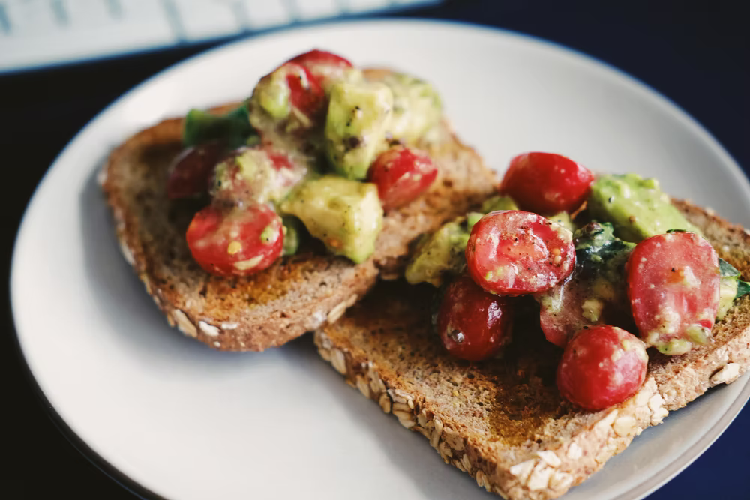
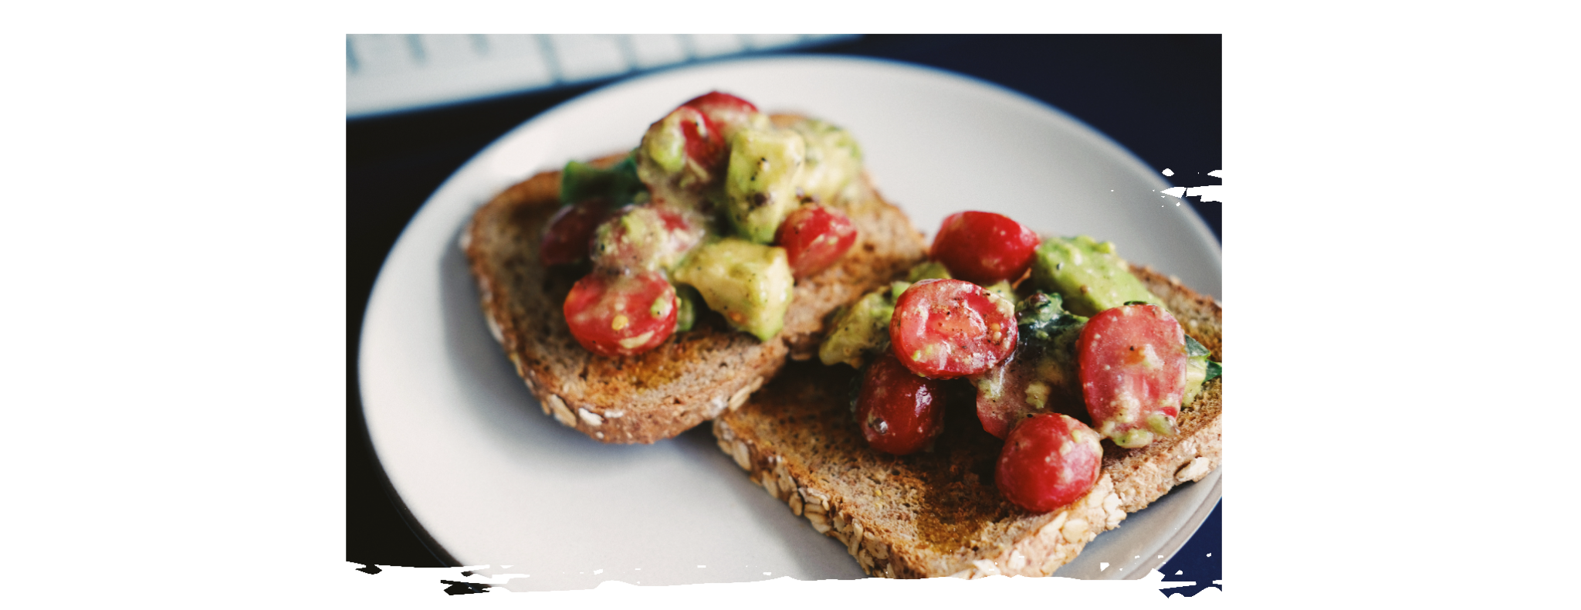

Toast with tomato
II Ingredients  - 2 to 4 slices of French or Italian loaf bread  - Herbed Boursin cheese, about 2 Tbsp per slice of bread  - 1 medium to large vine-ripened tomato  - Coarse salt (like fleur de sel or even just Kosher salt)  - Freshly ground black pepper | Method  - Toast the bread.  - While the bread is toasting, slice the tomato into 1/4-inch slices.  - Once the bread is lightly toasted, spread one side with Boursin cheese. Top with a couple slices of tomato, overlapping if necessary. Sprinkle it with coarse salt and freshly ground black pepper.  Eat immediately.

